- 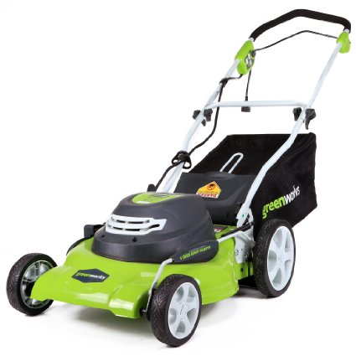

GreenWorks 25022 12 Amp Corded 20-Inch Lawn Mower

List Price: | $229.99
Price: | $179.00
You Save: | $50.99 (22%)
- 12 Amp Electric Motor delivers enough power to cut through the toughest grass
- Durable steel 20-Inch cutting deck gets the job done quicker and more efficiently
- 3-in-1 feature provides multiple options for grass clippings from rear bagging, side discharge and mulching capabilities for versatile needs
- 7 position height adjustment offers a range of cutting height from 1 1/2-Inch to 3 3/4-Inch for the perfect cut on all grass types
- Wide 10-Inch rear wheels and 7-Inch front wheels. Please lift the rear discharge cover to find the mulching plug.

- 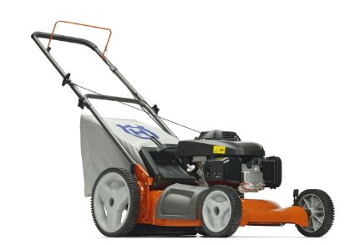

Husqvarna 7021P 21-Inch 160cc Honda GCV160 Gas Powered 3-N-1 Push Lawn Mower With High Rear Wheels (CARB Compliant)

Price: | $299.95
- 21-inch, gas-powered push lawn mower with 160cc Honda GVC160 engine, ideal for smaller yards
- 3-in-1 cutting system--mulch, rear bag, and side discharge
- 12-inch rear wheels increase maneuverability over a variety of terrain
- Adjustable handle for ergonomic operation; folds for storage
- 7021P is compliant for the state of California

- 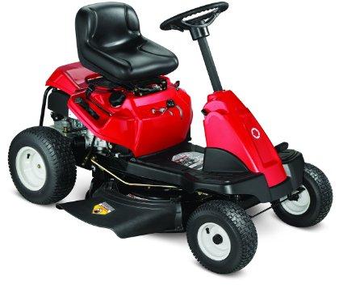

Troy-Bilt 420cc OHV 30-Inch Premium Neighborhood Riding Lawn Mower

List Price: | $1,221.75
Price: | $1,099.99 Free Scheduled Delivery
You Save: | $121.76 (10%)

- This neighborhood mower is ideal for standard land owners with a medium sized landscape and relatively even terrain
- Powerful 420cc Single Troy-Bilt Engine with top forward speeds of 4.25 MPH and a 6-speed transmission
- Manual power take-off for fast and easy blade engagement
- The 30-Inch cutting deck featuring 5 adjustable settings couples the benefits of a standard riding mower with the size of a wide cut walk behind mower
- 18-Inch turning radius with 13x5-inch front wheels and 16x6.5-inch rear wheels

Special Shipping Information: This product may not be available for 1 or 2 day shipping due to federal regulations that require it to ship via ground ship methods only. This product can only be shipped within the 48 contiguous states.

- 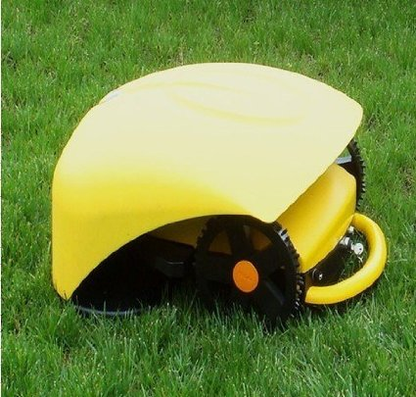

Intelligent Robot Lawn Mower+li-ion Battery+auto Recharged+ Remote Controller

Price: | $1,565.00 & FREE Shipping
- DHL, Fedex,Or EMS or TNT shipping. Goods would arrive in 3-5 working days after goods shipped. Also we mark the invoice lower than 100USD to help it clean customer quickly.
- Intelligent Running:Mover Robot can control her wheels through embedded intelligent software,to achieve progress,retreat,turn left,turn right, and other basic movement.The intelligent running can be automatically adjusted according to different mow algorithm.
- 2Prevention of Collisions:Built-in automatic ultrasonic sensors detect obstacles in front and automatically avoid collisions. 3. Blades security control After entered the region,starting cutting blades.When a person or animal is near the blades Mower Robot will automatically stop. 4. Intelligent Test lawn: Automatically detect the length of grass, dense, controlled cutting process.
- 5..Electronic fence(Setting up the work region) The fence made with electronic component cable can control the cutting scope effectively. 6.Intelligent Safety Testing:It can estimate whether the circuit is overload and if it is Mower Robot will stop work to protect the inside circuit. .
- 7. Back charging automatically 8.Taking rainshelter automatically 9. Remote control function:Through telecontrol commands, achieving directional walking by mowing patterns, obstacle avoidance, switches and other functions.
- 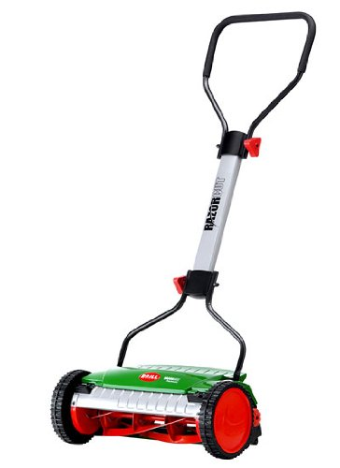
Click to open expanded view

Brill 78371 Razorcut 38 15-Inch Reel Push Lawn Mower

List Price: | $249.99
Price: | $159.99
You Save: | $90.00 (36%)
Only 16 left in stock.
- Silent cut design - reel blades do not contact the cutting bar
- No gas or fumes
- Ergonomically shaped frame with foam rubber handle - more comfortable to push
- Sealed bearings - means no extra maintenance is needed
- Flame Hardened steel blades - go years before sharpening is necessary

